FIN3210 Week 7 Assignment Report

Ma Kexuan 120090651

**Abstract**

This report extracted market characteristics such as close price, volume, to analyze time series variation between BTC and ETH. Also evaluate the quality of 2 different ICO white papers.

**Data Preprocessing**

The preprocessing procedures and some interpretations of the code are described in the code attached to the report.

**Questions**

Q1: The price time-series for BTC and ETH are attached as follows:

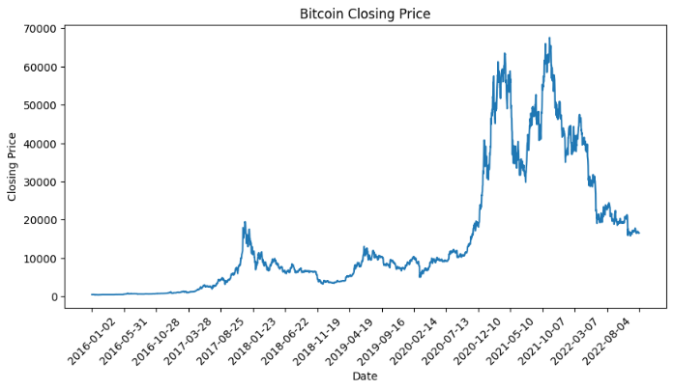

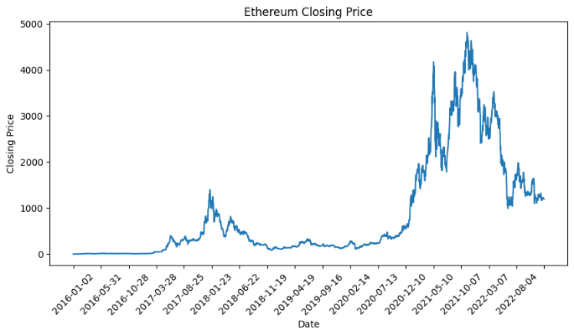

For Bitcoin, it shows a long-term upward trend, despite significant volatility. The price has gone through multiple boom and bust cycles but has generally increased over time. There are periods of extreme volatility, with sharp increases followed by steep declines. The peaks in price appear to be becoming more extreme over time, which is characteristic of BTC's historical price movement. BTC often experiences cycles that correlate with various factors, including halving events (where the reward for mining new blocks is halved, occurring approximately every four years), regulatory news, and market sentiment.

For Ethereum, it also displays a long-term upward trend with a pattern of growth that mirrors the wider adoption and development of decentralized applications on its platform. Like BTC, ETH exhibits periods of high volatility. The price movements seem to be somewhat correlated with BTC, suggesting that market sentiment in the cryptocurrency space can affect multiple assets simultaneously. ETH's price also shows cyclical patterns that may be influenced by the development milestones of the Ethereum network, such as upgrades to the protocol.

Q2: The two different whitepaper leads to totally distinct ICO results. Here I’ll mainly focus on the format as well as the content of these two whitepapers to give my discussion.

Format:

The Filecoin whitepaper presents a structured, professional layout. It includes detailed sections like an abstract, introduction, technical architecture, incentive structures, and an extensive list of references. This format demonstrates thorough planning and a clear understanding of the technology and business model.

While in the Argute one, while also structured, lacks the depth seen in Filecoin's presentation. It includes sections on the project's background, development plan, and ICO details, but there's a noticeable lack of technical depth. The presentation style is more general and less focused on technical specifics.

Content:

The content of Filecoin's whitepaper is highly technical and detailed. It discusses innovative solutions to data storage and retrieval, underpinned by a robust blockchain protocol. The paper outlines a clear problem statement, followed by a comprehensive solution, indicating a deep understanding of the market and technology.

Arqute's whitepaper, while presenting a unique idea in the animation industry, falls short in offering substantial technical and market analysis. The focus is more on the concept and less on the execution, lacking in-depth discussion on blockchain integration or detailed market analysis. The content appears more speculative and less grounded in rigorous technical planning.

In summary, Filecoin's whitepaper stands out for its technical depth, clarity in problem-solving, and detailed market and technology analysis. Arqute's whitepaper, while presenting an interesting concept, lacks the technical depth and comprehensive market analysis, which might have contributed to its failure in attracting sustained investor interest. These differences in format and content quality significantly contribute to the perceived credibility and potential success of an ICO.